SMASHWORD IMAGES

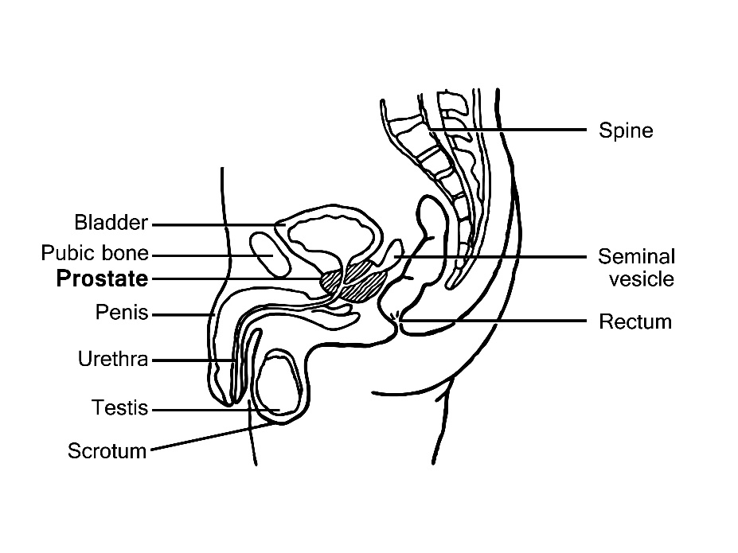

Chapter 2: Unigeniture Zone
(Image: Courtesy of Wikipedia)

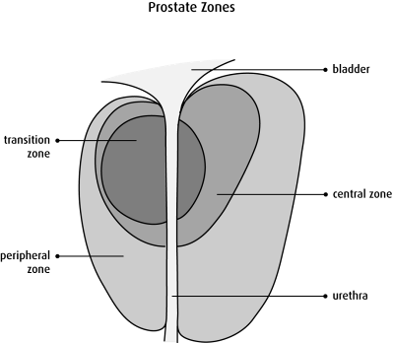
Chapter 2: Prostate Zones
(Image: Courtesy of Canadian Cancer Society)

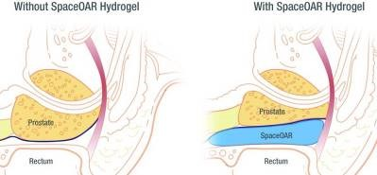
Chapter 8.1 SpaceOAR Hydrogel
(Image: Courtesy of Augmenix Inc.)

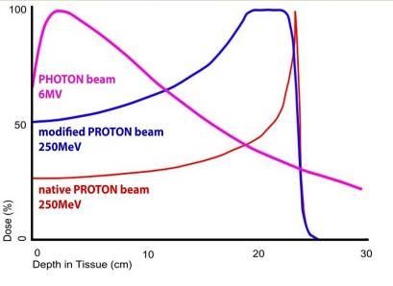
Chapter 8.4 Proton Beam Therapy – Dose to Depth Curve
(Image: Courtesy of Wikipedia)

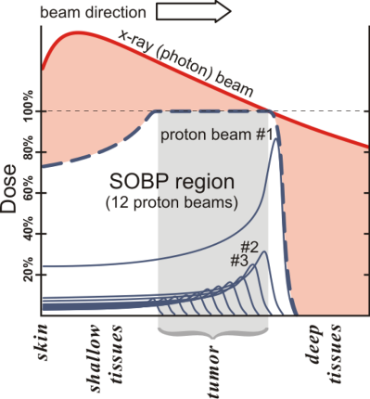
Chapter 8.4 Proton Beam Therapy – Spread-Out Bragg Peak
(Image: Courtesy of Wikipedia)

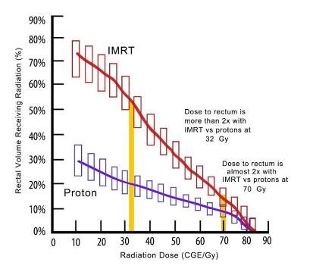
Chapter 8.4 PBT – Radiation Dose to the Rectum (PBT vs X-Ray)
(Image: Courtesy of Wikipedia)

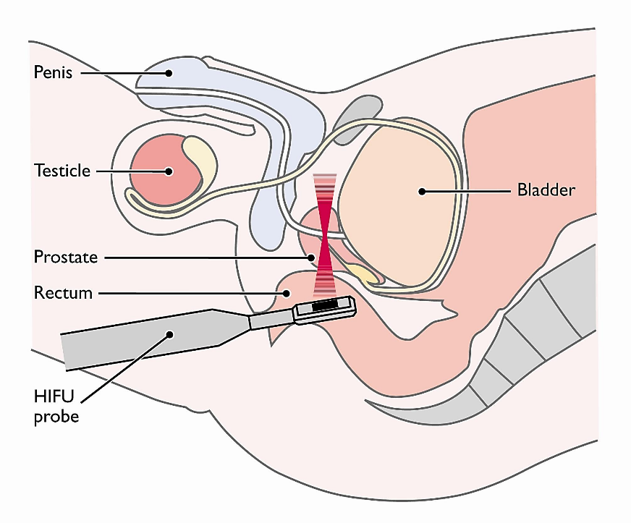

Chapter 11: HIFU
(Image: Courtesy of Orchid Cancer, St Bartholomew’s Hospital, London)

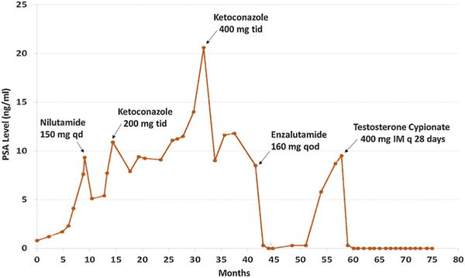
Chapter 13: Hormone Therapy
Prostate-specific antigen (PSA) levels over time in response to the hormonal therapies indicated.
(Image: Extreme Response to High-dose Testosterone in BRCA2- and ATM-mutated Prostate Cancer. Teply, Benjamin A. et al. European Urology, Volume 71, Issue 3, 499)

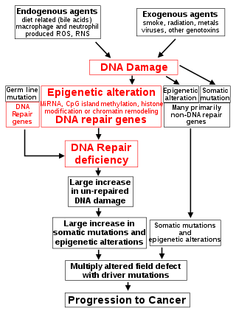
Chapter 15: The Central Role of DNA Damage and Epigenetic defects in DNA repair genes in cancer
(Image: Courtesy of Bernstein 0275

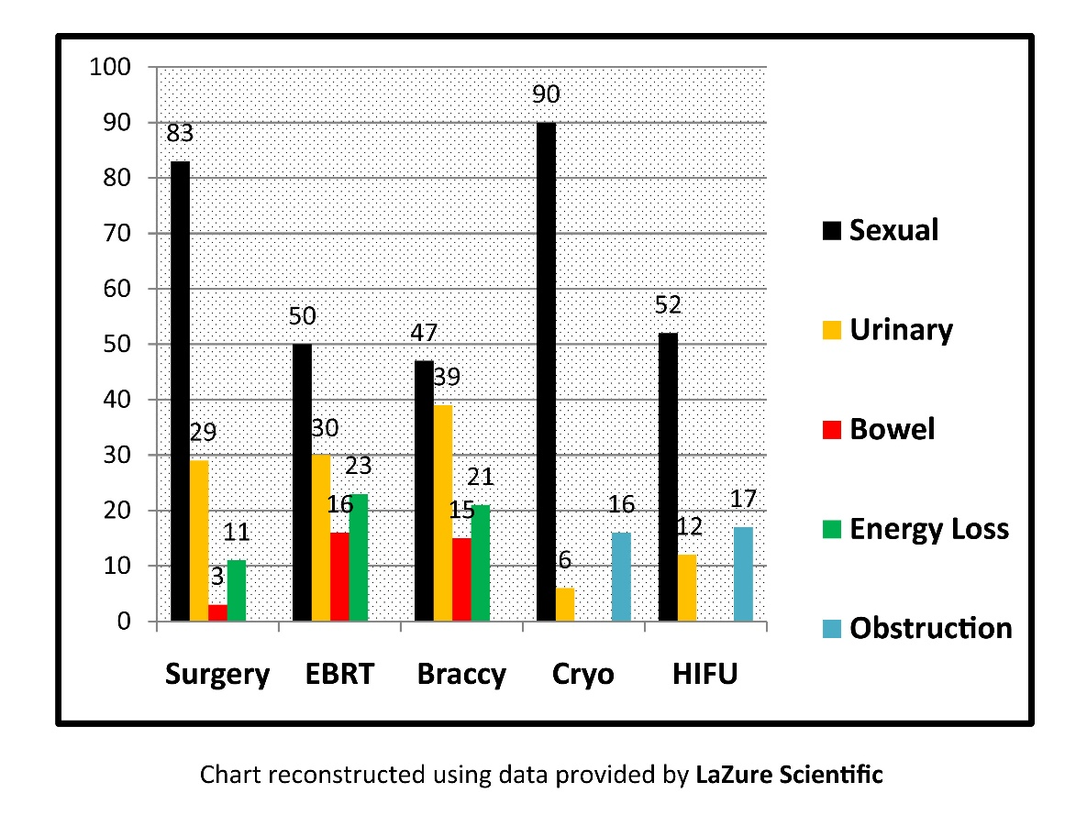
Chapter 24: Side Effects of Current treatments

